POLYCYSTIC OVARY SYNDROME

PROJECT REPORT

Project submitted in partial fulfilment of the degree BACHELOR OF TECHNOLOGY IN
COMPUTER SCIENCE AND ENGINEERING

Submitted by

P.Sandhya(O170205)
B.Priyanka(O170073)
G.Madhuri(o170101)
Sk.Shaziya(o170108)
G.kamakshi(o170148)
B.varudhini(o170149)

Under the supervision of Ms .Soumya m madam

Dept. of Computer Science and Engineering ,

RAJIV GANDHI UNIVERSITY OF KNOWLEDGE TECHNOLOGIES ONGOLE CAMPUS

AUG 2022

Approval Sheet
This thesis/dissertation entitles POLYSCYSTIC OVARY SYNDROME by p.sandya(o170205)B.Priyanka(o170073),G.Madhuri(o170101),SK.Shaziya(o170108),G.Kamakshi(o170148),G.Varudhini(o170149) is degree of Bachelor of Technologies.

Examiners

Supervisor (s)

Chairman

Date:

Place:

Declaration

I declare that this written submission represents my ideas in my own words and where others' ideas or words have been included, I have adequately cited and referenced the original sources. I also declare that I have adhered to all principles of academic honesty and integrity and have not misrepresented or fabricated or falsified any idea/data/fact/source in my submission. I understand that any violation of the above will be cause for disciplinary action by the Institute and can also evoke penal action from the sources which have thus not been properly cited or from whom proper permission has not been taken when needed.

P.Sandya
iD: O170205 _
B.Priyanka
ID: O170073 _
G.Madhuri
ID: O170101
SK.shaziya
ID: O170108
G.Kamakshi
ID: O170148
B.Varudhini
ID:
o170149


RAJIV GANDHI UNIVERSITY OF KNOWLEDGE TECHNOLOGIES DEPARTMENT OF COMPUTER SCIENCE & ENGINEERING

CERTIFICATE

This is to certify that the project report entitled “POLYCYSTIC OVARY SYNDROME” submitted by P.Sandhya(o170205),B.Priyanka(o170073),G.Madhuri(o170101),SK.shaziya(o170108).G.Kamakshi(o170148),B.varudhini(o170149) to Department of Computer Science and Engineering, Rajiv Gandhi University of Knowledge Technologies, ONGOLE, during the academic year 2021- 2022 is a partial fulfilment for the award of Under graduate degree of Bachelor of Technology in Computer Science and Engineering is a bonafied record carried out by him/her under my supervision. The project has fulfilled all the requirements as per as regulations of this institute and in my opinion reached the standard for submission.

Ms . Soumya m, Assistant Professor, Dept. of C.S.E., RGUKT ONGOLE.

Date:
Place: ONGOLE

ACKNOWLEDGEMENT

We are highly indebted to Ms. Soumya m mam for their guidance and constant supervision as well as for providing necessary information regarding the project and also for their kind co-operation, encouragement and their support in completing the project.
I would like to express my special gratitude and thanks to our COMPUTER SCIENCE AND ENGINEERING branch HOD Mr. M. SAMPATH and Director of ONGOLE RGUKT
Prof. B. Jayarami Reddy for giving me such attention and time.
We have taken efforts in this project. However, it could not have been possible without the kind support and help of many individuals and RGUKT. We would like to extend my sincere thanks to all of them.
My thanks and appreciate also go to my college in developing the project and people who have willingly helped me out with their abilities.

With Sincere Regards,

P. SANDHYA(O170205) B.PRIYANKA(O170073)
G.MADHURI(O170101)

SK.SHAZIYA(O170108)
G.KAMAKSHI(O170148) B.VARUDHINI(O170149)

ABSTRACT

To solve this pcos problem we will develop a website to aknowledge them properly about this pcos.
We wil set them know how to maintaian proper Diet and practice ,Yoga aasana's for perfect menstrual cycle through our website.
To remaind their period's date they will be redirectes to note their period's date and the date will be saved in google calender and it will remind them every month through notification.
Some preventive measures will be provided in our website to avoid pcos problem.
In our website we can see the medicines for solve pcos problem.Which are low cost and which are available to people near by medical stores.
Here we mention the symtomes of polycystic ovary syndrome (PCOS).By this we can take care about our health to not get pcos problem.We know prevention is more better than cure so we mention here about precations to avoid polycystic ovary syndrome (PCOS) problem.
To know more about the polycystic ovary syndrome (PCOS) problem we mention the causes and effects of polycystic ovary syndrome (PCOS)

INDEX

CHAPTER 1

- INTRODUCTION

Polycystic ovary syndrome (PCOS) is a condition in which the ovaries produce an abnormal amount of androgens, male sex hormones that are usually present in women in small amounts. The name polycystic ovary syndrome describes the numerous small cysts (fluid-filled sacs) that form in the ovaries. However, some women with this disorder do not have cysts, while some women without the disorder do develop cysts.

Ovulation occurs when a mature egg is released from an ovary. This happens so it can be fertilized by a male sperm. If the egg is not fertilized, it is sent out of the body during your period.

In some cases, a woman doesn’t make enough of the hormones needed to ovulate. When ovulation doesn’t happen, the ovaries can develop many small cysts. These cysts make hormones called androgens. Women with PCOS often have high levels of androgens. This can cause more problems with a woman’s menstrual cycle. And it can cause many of the symptoms of PCOS.

Treatment for PCOS is often done with yoga,medicine,diet . This can’t cure PCOS, but it helps reduce symptoms and prevent some health problems.Women with PCOS may be at higher risk for type 2 diabetes, high blood pressure, heart problems, and endometrial cancer.

CHAPTER 2

- SYSTEM ANALYSIS

The system analysis includes existing system limitations, proposed system with features, and quirements of the system which includes diet plan,precations,symptomes,yoga asanans,medical plan for pcos problem.

- Existing system:

- Need to consult the Doctor

- They don't have awareness about the Disease

- They don't know the prevention
- Don't know of about pcos problem
- Proposed System:
We propose a modular solution to the problem of Pcos manually by creating static Web page
- Information about the diet plan

- Information about how to overcome the pcos problem.

- Information about the medical plan

- information about the symptoms and effects.

- inforamtion about prevention .

CHAPTER 3

- REQUIREMENT ANALYSIS

The System Environment includes the basic requirements related to the system are software and hardware requirements.

- Hardware Requirements

- RAM :4GB

- Hard disk : Minimum 500 GB

- Processor : AMD-A9-9420 Radeon

- Input Devices : keyboard

- Software Requirements

- Technologies : HTML,CSS,JAVASCRIPT

- Version : HTML4

- Operating System : windows or Linux

- IDE : google chrome,visual stdio

CHAPTER 4
SYSTEM DESIGN

The most creative and challenging phase of the life cycle is system design. The term design describes a final system and the process by which it is developed. It refers to the technical specifications that will be applied in implementations of the candidate system. The design may be defined as “the process of applying various techniques and principles for the purpose of defining a device, a process or a system with sufficient details to permit its physical realization”.

UML
UML (Unified Modeling Language) is a standard language for specifying, visualizing, constructing, and documenting the artifacts of software systems. UML was created by the Object Management Group (OMG) and UML 1.0 specification draft was proposed to the OMG in January 1997. It was initially started to capture the behavior of complex software and non- software system and now it has become an OMG standard.
UML is popular for its diagrammatic notations. We all know that UML is for visualizing, specifying, constructing and documenting the components of software and nonsoftware systems. Hence, visualization is the most important part which needs to be understood and remembered.
UML notations are the most important elements in modeling. Efficient and appropriate use of notations is very important for making a complete and meaningful model. The model is useless, unless its purpose is depicted properly.

Hence, learning notations should be emphasized from the very beginning. Different notations are available for things and relationships. UML diagrams are made using the notations of things and relationships. Extensibility is another important feature which makes UML more powerful and flexible.

Goals of UML

A picture is a worth of thousand words, this idiom absolutely fits describing UML. Object-oriented concepts were introduced much earlier than UML. At that point of time, there were no standard methodologies to organize and consolidate the object-oriented development. It was then that UML came into picture.
There are a number of goals for developing UML but the most important is to define some general purpose modeling language, which all modelers can use and it also needs to be made simple to understand and use.
UML diagrams are not only made for developers but also for business users, common people, and anybody interested to understand the system. The system can be a software or non-software system. Thus it must be clear that UML is not a development method rather it accompanies with processes to make it a successful system.
In conclusion, the goal of UML can be defined as a simple modeling mechanism to model all possible practical systems in today’s complex environment.
- Usecase Diagram:

A Use Case Diagram is a diagram that help system analyst to discover the requirements of the target system from the user's perspective.
Use case diagrams are used to gather the requirements of a system including internal and external influences. These requirements are mostly design requirements. Hence, when a system is analyzed to gather its functionalities, use cases are prepared and actors are identified
When the initial task is complete, use case diagrams are modelled to present the outside view.

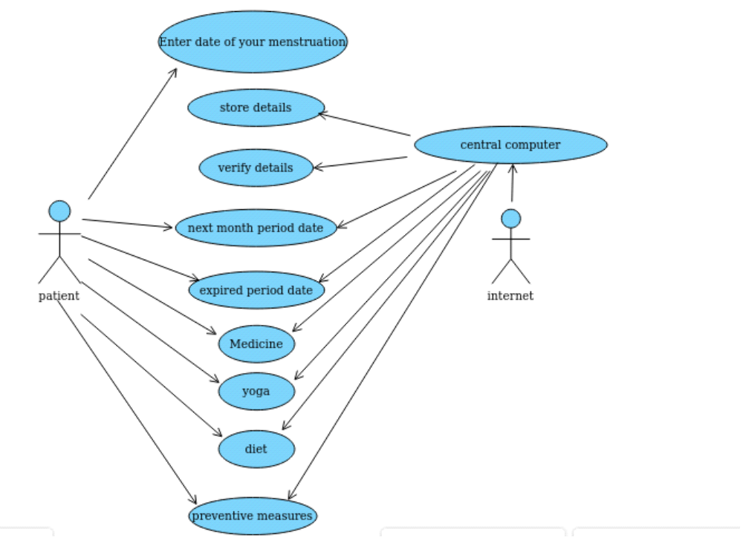

Fig 4.1 Use Case

Activity diagram is another important diagram in UML to describe the dynamic aspects of the system.
Activity diagram is basically a flowchart to represent the flow from one activity to another activity. The activity can be described as an operation of the system. The control flow is drawn from one operation to another. This flow can be sequential, branched, or concurrent. Activity diagrams deal with all type of flow control by using different elements such as fork, join, etc.

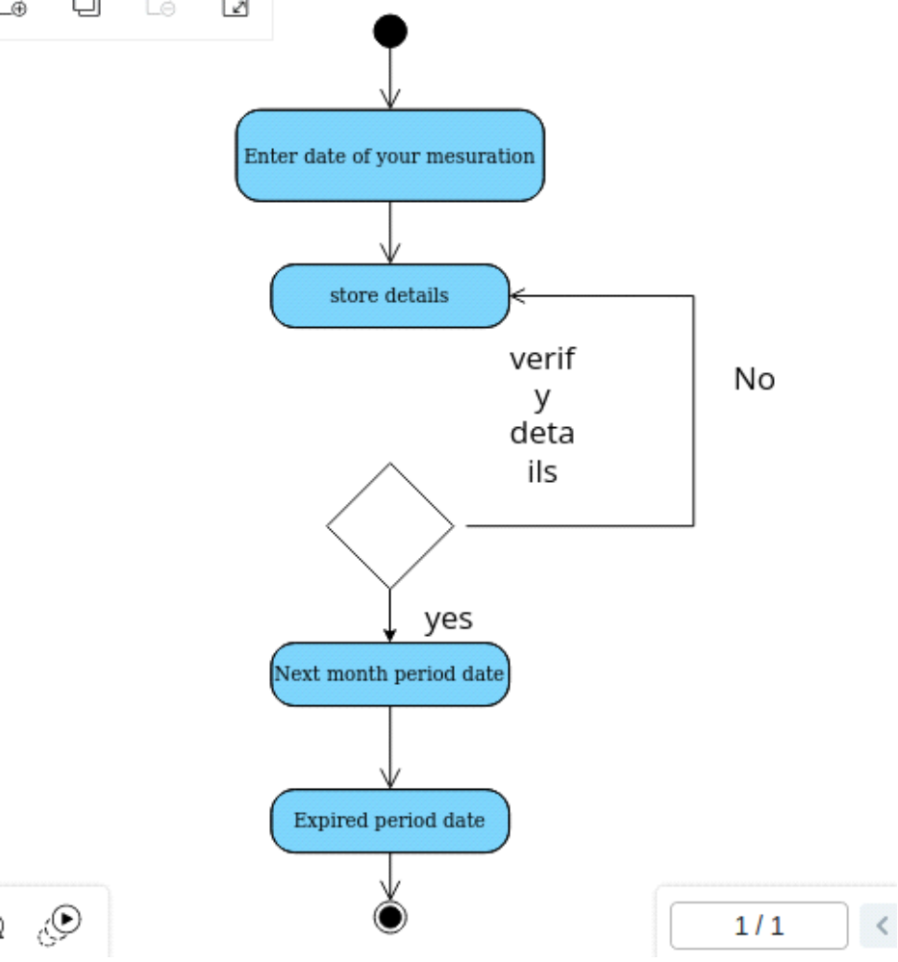
Fig 4.2 Activity Diagram

CHAPTER 5

- SOFTWARE ENVIRONMENT

- HTML:
HTML stands for HyperText Markup Language. It is used to design web pages using a markup language. HTML is the combination of Hypertext and Markup language. Hypertext defines the link between web pages. A markup language is used to define the text document within the tag which defines the structure of web pages. This language is used to annotate (make notes for the computer) text so that a machine can understand it and manipulate text accordingly. Most markup languages (e.g. HTML) are human-readable. The language uses tags to define what manipulation has to be done on the text.

Features of HTML :
- HTML stands for Hyper Text Markup Language
- HTML is the standard markup language for creating Web pages
- HTML describes the structure of a Web page
- HTML consists of a series of elements
- HTML elements tell the browser how to display the content
- HTML elements label pieces of content such as "this is a heading", "this is a paragraph", "this is a link", etc..
- CSS
Cascading Style Sheets (CSS) is a stylesheet language used to describe the presentation of a document written in HTML or XML (including XML dialects such as SVG, MathML or XHTML). CSS describes how elements should be rendered on screen, on paper, in speech, or on other media.

- Features of CSS :
First and foremost, It’s FREE.
It has several important prebuilt common elements as follows
Base: Elements like <p>, <h1…h6>, topography etc.
Grids: Responsive grids.
Forms: Multi-columns, stacked forms, aligned forms, grouped inputs, etc.
Tables: Base tables with borders, stripping, etc.
Buttons: Button effects like focus, hover, active, etc.
Menus: Dropdowns, scrollable menus, vertical menus, responsive menus .

- JAVASCRIPT :
JavaScript (js) is a light-weight object-oriented programming language which is used by several websites for scripting the webpages. It is an interpreted, full-fledged programming language that enables dynamic interactivity on websites when applied to an HTML document. It was introduced in the year 1995 for adding programs to the webpages in the Netscape Navigator browser. Since then, it has been adopted by all other graphical web browsers. With JavaScript, users can build modern web applications to interact directly without reloading the page every time. The traditional website uses js to provide several forms of interactivity and simplicity.
- Features of JAVASCRIPT :

- DOM Manipulation
- Functions as First-Class Objects
- Javascript as a Client-Side Language
- Platform Independent
- The Syntax is Similar to Java
- Date and Time
- Prototype-Based Object Model
- Form Validation
- Detecting the User’s Browser and OS
- Ability to Create Functions in the Script

- IMPLEMENTATION

- SAMPLE CODE :
<!DOCTYPE HTML>
<html>
<head>
<meta name="viewport" content="width=device-width, initial-scale=1">
<style>
p {
text-align: bottom-right;
font-size: 20px;
margin-top: 0px;
color:crimson;
text-shadow: crimson;
}
.button{
border:none;
padding:15px 32px;
text-align:center;
text-decoration:none;
display:inline-block;
font-size:16px;
margin:4px 2px;
cursor:pointer;
}
.disabled{
opacity:0.6;
cursor:not-allowed;}
div{
width:300px;
padding:50px;
margin:50px;
height:50px;}
body{
background-image:url("https://lolipharmainternational.com/wp-content/uploads/2020/09/PCOS-COPERTINA-980x551.png");
/*background-repeat:repeat-x;*/
}
.coundownContainder{
position:relative;
margin:a;
display: flex;
justify-content: center;
align-items:center;
background:linear-gradient(270deg,#051817,#0e3839);
height:180px;
width:350px;
color:cadetblue;
align-items: center;
text-shadow:1px 1px 1px;
border-radius: 15px;
border:2px solid silver;
box-shadow: 0 0 5px 25px;
font-size:150%;

}
</style>
</head>
<body>

<button type="button" class="button disabled" onclick="check1()" style="font-size:25px">MEDICINE</button>
<button type="button" class="button disabled" onclick="check2()" style="font-size:25px">DIET</button>
<button type="button" class="button disabled" onclick="check3()" style="font-size:25px">YOGA</button>
<button type="button" class="button disabled" onclick="check4()" style="font-size:25px">PREVENTIVE MEASURES</button>
<button type="button" class="button disabled" onclick="check5()" style="font-size:25px">EFFECTS AND SYMPTOMS</button><br>
<div>
<p style="color:black;text-align:center;font-size:40px;"><b>Enter Date When You get period in this month</b></p>
</div>
<table class="coundownContainder" align="right">
<label for="mensuration" style="font-size:20px"><b>Select Date:</b></label>
<input type="date" id="dateInput" name="mensuration"
style="font-size:20px">
<br> <br><button type="button" class="button disabled" onclick="countDown()" style="font-size:20px">Click for countdown!</button><br>
<tr>
<td colspan="4">Menstruration countdown</td>
</tr>
<tr>
<td id="days">00</td>
<td id="hrs">00</td>
<td id="min">00</td>
<td id="sec">00</td>
</tr>
<tr>
<td>Days</td>
<td>hrs</td>
<td>min</td>
<td>sec</td>
</tr>
<tr><td>left for next period</td></tr>
</table>
<p id="demo1"></p>
<p id="demo"></p>

<script>
// Set the date we're counting down to
function countDown(){
var input=document.getElementById("dateInput").value;
var dt=new Date(input);
input=new Date(input);
dt.setMonth(input.getMonth()+1);
const month=dt.getMonth();
document.getElementById("demo1").innerHTML="Next Date is : "+dt;
document.getElementById("demo").innerHTML="Given Date is : "+input;

var countDownDate = new Date(dt).getTime();

// Update the count down every 1 second
var x = setInterval(function() {

// Get today's date and time
var now = new Date().getTime();

// Find the distance between now and the count down date
var distance = countDownDate - now;

// Time calculations for days, hours, minutes and seconds
var days = Math.floor(distance / (1000 * 60 * 60 * 24));
var hours = Math.floor((distance % (1000 * 60 * 60 * 24)) / (1000 * 60 * 60));
var minutes = Math.floor((distance % (1000 * 60 * 60)) / (1000 * 60));
var seconds = Math.floor((distance % (1000 * 60)) / 1000);

// Output the result in an element with id="demo"
document.getElementById("days").innerHTML = days
document.getElementById("hrs").innerHTML = hours
document.getElementById("min").innerHTML = minutes
document.getElementById("sec").innerHTML = seconds ;
// If the count down is over, write some text
if(distance <1 && distance>0){
alert.document("time arrived for period");
}
if (distance < 0) {
clearInterval(x);
document.getElementById("demo").innerHTML = "EXPIRED (do you get this month period)";
}
}, 1000);
}
</script>
<script>

function check1() {

// Create anchor element.
var a = document.createElement('a');

// Create the text node for anchor element.
var link = document.createTextNode("medicine");

// Append the text node to anchor element.
//a.appendChild(link);

// Set the title.
a.title = "medicine";

// Set the href property.
window.open(
a.href = "file:///home/rgukt/Downloads/medicine.html","_blank");

// Append the anchor element to the body.
document.body.appendChild(a);
}
</script>
<script>

function check2() {

// Create anchor element.
var a = document.createElement('a');

// Create the text node for anchor element.
var link = document.createTextNode("diet");

// Append the text node to anchor element.
//a.appendChild(link);

// Set the title.
a.title = "diet";

// Set the href property.
window.open(
a.href = "file:///home/rgukt/Downloads/diet.html","_blank");

// Append the anchor element to the body.
document.body.appendChild(a);
}
</script>
<script>

function check3() {

// Create anchor element.
var a = document.createElement('a');

// Create the text node for anchor element.
var link = document.createTextNode("yoga ");

// Append the text node to anchor element.
//a.appendChild(link);

// Set the title.
a.title = "yoga";

// Set the href property.

window.open(
a.href = "file:///home/rgukt/Downloads/YOGAAsanas(1).html","_blank");

// Append the anchor element to the body.
document.body.appendChild(a);
}
</script>
<script>
function check4() {

// Create anchor element.
var a = document.createElement('a');

// Create the text node for anchor element.
var link = document.createTextNode("preventive measures");

// Append the text node to anchor element.
//a.appendChild(link);

// Set the title.
a.title = "preventive measures";

// Set the href property.
window.open(
a.href = "file:///home/rgukt/Downloads/preventive.html","_blank");

// Append the anchor element to the body.
document.body.appendChild(a);
}
</script>
<script>
function check5() {

// Create anchor element.
var a = document.createElement('a');

// Create the text node for anchor element.
var link = document.createTextNode("effects and symptoms");

// Append the text node to anchor element.
//a.appendChild(link);

// Set the title.
a.title = "effects and symptoms";

// Set the href property.
window.open(
a.href = "file:///home/rgukt/Downloads/symptomsandeffects.html","_blank");

// Append the anchor element to the body.
document.body.appendChild(a);
}
</script>

</body>
</html>

CHAPTER 7

- TESTING

After the completion of the development process,application needs to move to Testing part.Testing plays a major role in complete development life cycle. It is the process to check whether the project meets the customers requirements. We had done Unit Testing, Integrated Testing, System Testing. For this we had made a detailed testing plan with our team members.

- Testing Objectives

- To make sure whether system meets user requirements or not.

- To make sure that during the operation, incorrect input, processing and output will bedetected.
- To see that when correct inputs are fed to the system the outputs are correct.

- To verify that the controls incorporated in the same system as intended.

- Unit Testing

Unit Testing is undertaken when a module has been created and successfully reviewed. In order to test a single module we need to provide a complete environment i.e. besides the module we would require:

- The procedures belonging to other modules that the module under test calls.

- Non local data structures that module accesses.

- A procedure to call the functions of the module under test with appropriate parameters.

Unit tests are typically automated tests written and run by software developers to ensure that a section of an application (known as the "unit") meets its design and it behaves as intended. In Procedural Programming, a unit could be an entire module, but it is more commonly an individual function or procedure. In object-oriented programming, a unit is often an entire interface, such as a class, or an individual method. By writing tests first for the smallest testable units, then the compound behaviours between those, one can build up comprehensive tests for complex applications.

To isolate issues that may arise, each test case should be tested independently. Substitutes such as method stubs, mock objects, fakes, and test harness can be used to assist testing a module in isolation.
During development, a software developer may code criteria, or results that are known to be good, into the test to verify the unit's correctness. During test case execution, frameworks tests that fail any criterion and report them in a summary. For this, the most commonly used approach is test - function - expected value.
Writing and maintaining unit tests can be made faster by using parameterized tests . These allow the execution of one test multiple times with different input sets, thus reducing test code duplication. Unlike traditional unit tests, which are usually closed methods and test invariant conditions, parameterized tests take any set of parameters. Parameterized tests are supported by TestNG, JUnit and its .Net counterpart, XUnit. Suitable parameters for the unit tests may be supplied manually or in some cases are automatically generated by the test framework. In recent years support was added for writing more powerful (unit) tests, leveraging the concept of theories, test cases that execute the same steps, but using test data generated at runtime, unlike regular parameterized tests that use the same execution steps with input sets that are pre-defined.

- INTEGRATIOTESTING
N
In this type of testing we test various integration of the project module by providing the input . The primary objective is to test the module interfaces in order to ensure that no errors are occurring when one module invokes the other module.
Integration testing (sometimes called integration and testing, abbreviated I&T) is the phase in software testing in which individual software modules are combined and tested as a group. Integration testing is conducted to evaluate the compliance of a system or component with specified functional requirements It occurs after unit testing and before system testing

Integration testing takes as its input modules that have been unit tested, groups them in larger aggregates, applies tests defined in an integration test plan to those aggregates, and delivers as its output the integrated system ready for system testing.
- System Testing
System testing is testing conducted on a complete integrated system to evaluate the system's compliance with its specified requirements.
System testing takes, as its input, all of the integrated components that have passed integration testig. The purpose of integration testing is to detect any inconsistencies between the units that are integrated together (called assemblages). System testing seeks to detect defects both within the "inter-assemblages" and also within the system as a whole. The actual result is the behaviour produced or observed when a component or system is tested.
System testing is performed on the entire system in the context of either functional requirement specifications (FRS) or system requirement specification (SRS), or both. System testing tests not only the design, but also the behaviour and even the believed expectations of the customer. It is also intended to test up to and beyond the bounds defined in the software or hardware requirements specification(s)
This testing is done on totally developed application to check whether it meets customers requirements. The test cases are alpha testing and beta testing.
7.4.1 Alpha Testing

Actually this testing is done by our testing team to check the individual modules functions accurately or not. We plan the testing that contains all the testing methods.From starting session to ending session each and every module is tested by our team whether it meets out functioning requirements and customer needs.

CHAPTER 8
SAMPLE SCREENSHOTS FOR PCOS:
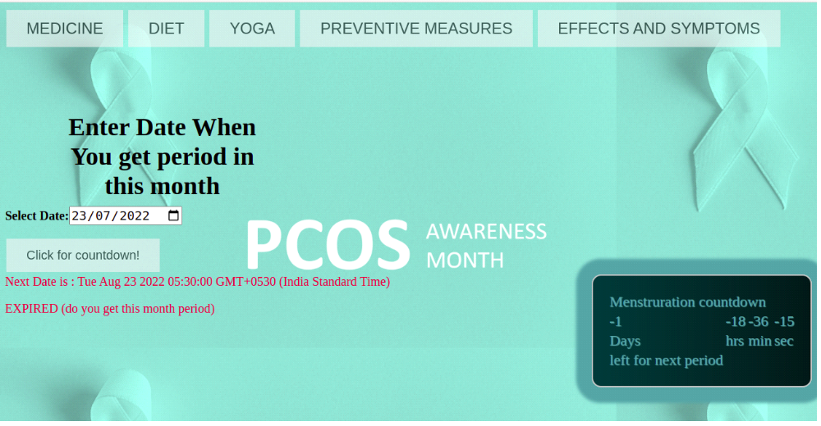

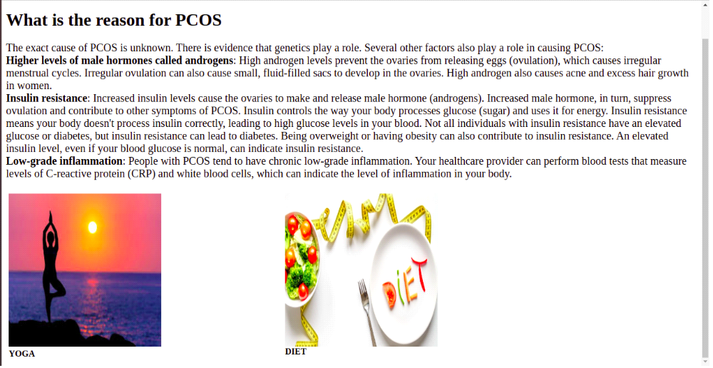

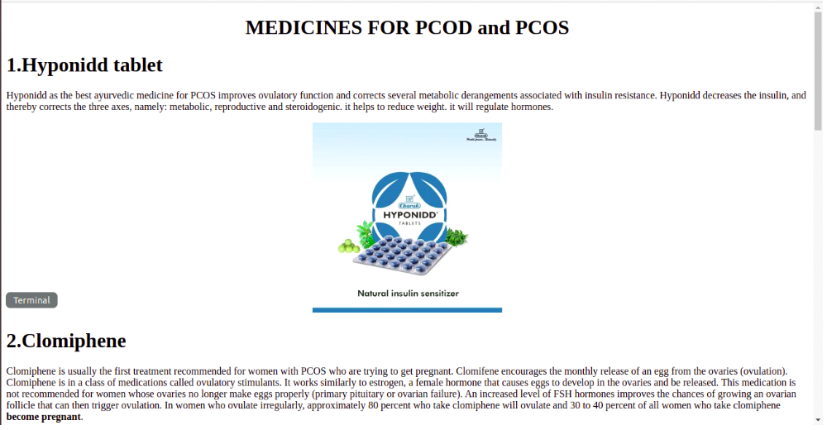

CHAPTER 9

- CONCLUSION
From a proper analysis of positive points and constraints on the component, it can be safely concluded that the product is a highly efficient component. This application is working properly and meeting to all people requirements. This web application can be easily plugged in many other systems. There have been numbers cases of computer glitches, errors in content and most important weight of features is fixed in web application, So in the near future the so –called web application could be made more secure, reliable and dynamic weight adjustment .In near future this module of web application can be integrate with the module of automated processing system. The web application is based on problems occered in pcos ,in future this web application can be made such that it is used to know the information about pcos problem .

This application provides the following benefits :

✔ 24*7 Availability

✔ Security

✔ Flexible Architecture

- FUTURE SCOPE
FUTURE SCOPE In future, this web application can be used to give the the information about the pcos problems.
HERE we will provide the information about how to recover from the pcos problem.By providing information such as Diet, yoga asanasas, precautions , effects and symptoms, medicines.

REFERENCES

- https://www.google.com

